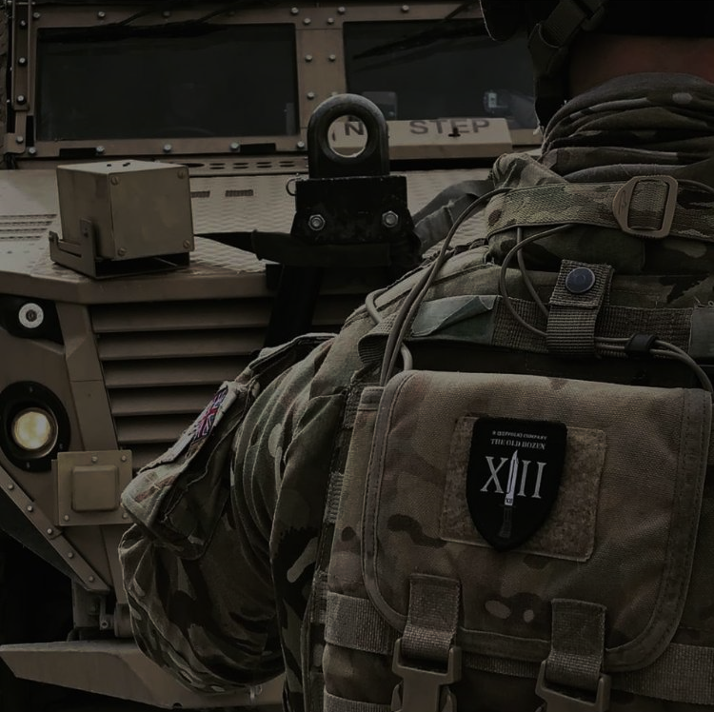
B (Suffolk) Company 1st Battalion (Vikings) The Royal Anglian Regiment

B (Suffolk) Company is a Light Role Infantry company trained to operate in a variety of terrain and environments. Recruited heavily from the county of Suffolk in East England the Company takes its lineage from the 12th Regiment of Foot and retains the nickname The Old Dozen. The Company has operated in India, Nigeria and recently returned from an operational deployment in Afghanistan providing Force protection to NATO advisors in Kabul.

B (Suffolk) Company, supported by the Battalion’s Reconnaissance Platoon and Sniper Platoon, will conduct a joint exercise with the Guards Jaeger Regiment in June as part of the bi-lateral Defence relationship with Finland. This will be the largest deployment to date of British troops to Finland and represents an excellent opportunity for both militaries to learn how to work together as we re-focus on conventional warfare.

The Royal Anglian Regiment consists of two Regular and one Reserve light role infantry battalions and is recruited from the East of England. 1st Battalion (Vikings) is based in London and has recently returned from operations in Afghanistan with A (Norfolk) Company still serving in South Sudan until July 2019. 2nd Battalion (Poachers) is based in Cyprus and provides a high readiness force for deployments in North Africa and the Middle East. The Reserve Battalion (Steelbacks) has locations throughout East England and supports the Regular battalions as well as their local communities. Since its formation the Regiment has deployed on operations to Afghanistan, Kuwait, Iraq, Bosnia, Northern Ireland, Sierra Leone and Croatia.

The modern Regiment and its forebears have a long and proud history dating back to 1685. The Royal Anglian Regiment was formed on 1st September 1964 and was the first of the large Infantry Regiments. (B (Suffolk) Company and is associated with the county of Suffolk in East England.

Useful links
https://www.army.mod.uk/who-we-are/corps-regiments-and-units/infantry/royal-anglian-regiment
www.royalanglianregiment.com
https://www.facebook.com/TheRoyalAnglianRegiment
https://www.army.mod.uk/
https://www.youtube.com/britisharmy
https://www.instagram.com/britisharmy
https://twitter.com/britisharmy
https://www.snapchat.com/add/britisharmyhq

B (suffolk) Company Kabul, Afghanistan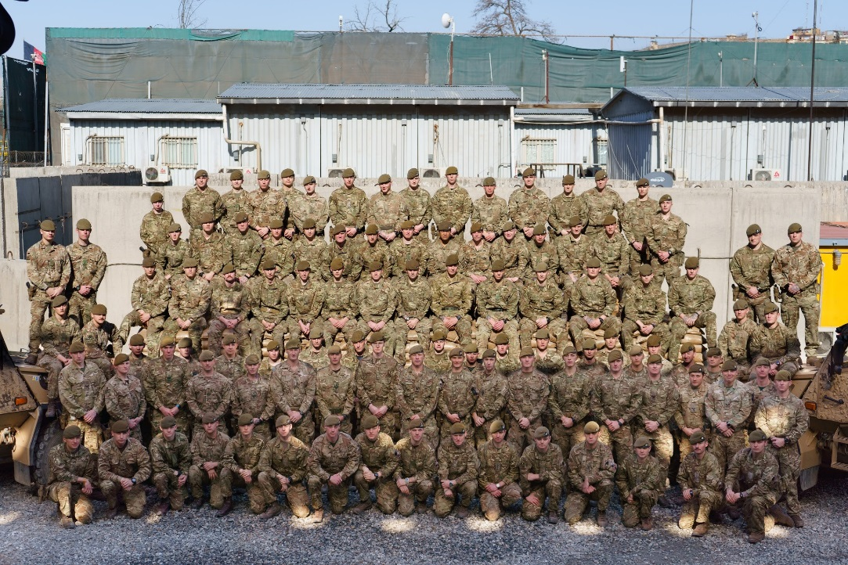 | D (Cambridgeshire) Qargha, Kabul  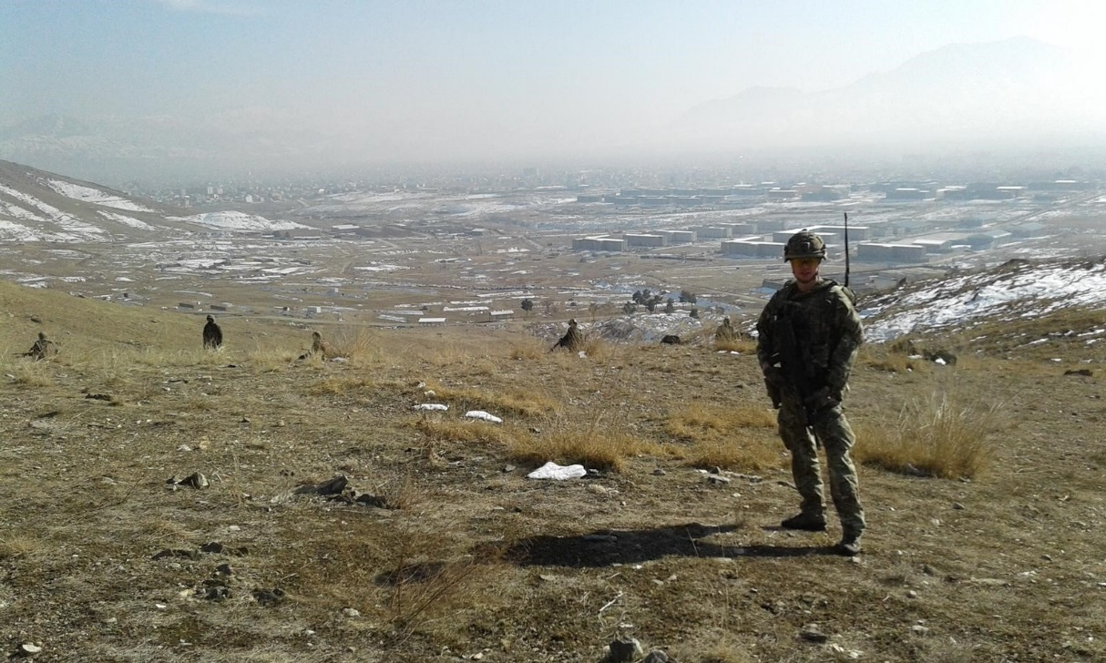
Training alongside the Royal Ghurka Rifles (RGR)  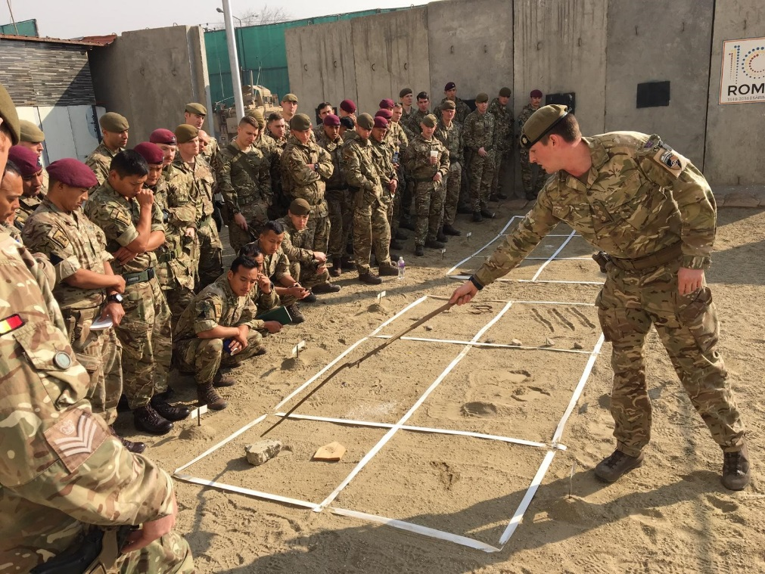 | Reconnaissance Platoon D (Cambridge) Company  